XPlore

Project progress report submitted

to

## MANIPAL ACADEMY OF HIGHER EDUCATION

For Partial Fulfillment of the Requirement for the

Award of the Degree

of

Bachelor of Technology

in

Computer and Communication Engineering

by

Rishabh Jain

Reg. No. 210953080

Shouvik Shome

Reg. No. 210953174

Bhavya Jain

Reg. No. 210953176

Under the guidance of

Dr. Vibha and Dr. Manoj T

Designation of Internal Guides

Department of I & CT

March 2024

**1. Introduction**

In today's interconnected world, travelers often find themselves in unfamiliar locations. To address this challenge, we propose a mobile travel application that leverages geolocation technology. This app will provide users with real-time access to critical resources based on their whereabouts. By pinpointing the user's location through GPS, the app can offer vital information like contact details for local emergency services, including police, ambulance, and fire stations. Additionally, the app can provide locality assistance, such as recommending nearby hospitals, pharmacies, and trusted translation services, ensuring a safe and secure travel experience for users.

**2. Literature Survey**

This proposed mobile travel application leverages geolocation technology to enhance user experience and safety. To achieve this, it's crucial to consider various aspects explored in existing research. UI/UX design plays a vital role, as evidenced by "Designing Intuitive User Interfaces for Location-Based Mobile Applications" which emphasizes information hierarchy, navigation patterns, and user testing methodologies [6]. Integration of geolocation APIs is essential, and "Enhancing User Experience in Mobile Applications through Geolocation Services" offers valuable insights by comparing features of different APIs like GPS accuracy and real-time tracking [2]. Real-time data retrieval through web scraping is addressed in "Utilizing Web Scraping Techniques for Real-Time Data Retrieval in Mobile Applications" which explores custom API development and data parsing techniques, potentially improving the current implementation for emergency contact information [3]. Emergency services integration aligns with the work presented in "Integration of Geolocation and Emergency Services APIs for Travel Safety Applications", which evaluates the effectiveness of various emergency service APIs for features like contact details and location-based routing [4]. Scalability and performance are crucial for a smooth user experience. "Scalability and Performance Considerations in Geolocation-Enabled Mobile Applications" offers strategies for optimizing geolocation services, ensuring the proposed application's reliability under increased user traffic [5]. Privacy and security are paramount. "Privacy and Security Implications of Geolocation Tracking in Mobile Applications" emphasizes user consent mechanisms and data protection best practices, which should be incorporated to maintain user trust [7]. While the proposed application focuses on emergency services, "Geolocation-Based Recommendations for Personalized Travel Experiences" offers additional functionalities by exploring location-based recommendations for travel assistance and local amenities, potentially enriching the user experience further [8].

**3. Problem Definition**

Traditional methods of finding local help, like searching online or relying on potentially outdated guidebooks, can be time-consuming and stressful. This lack of readily available, location-specific assistance can significantly hinder a safe and enjoyable travel experience. Therefore comes the need and dynamic functionality of our application into use.

Our application aims to bridge the gap between appls like trivago and bookmyshow combining the best features of both providing the users with the best user experience enabling the features of both applications in one.

**4. Objective**

Our proposed travel application aims to address the following objectives:

1. Reduce Traveler Anxiety: By providing instant access to location-specific resources, the app aims to alleviate the stress and uncertainty often associated with navigating unfamiliar places.
2. Enhance Emergency Response: Leveraging geolocation technology, the app will connect users directly with local emergency services, including police, ambulance, and fire stations, ensuring a faster and more efficient response during critical situations.
3. Optimize Locality Assistance*:* Extending beyond emergencies, the app will serve as a local guide, recommending nearby hospitals, pharmacies, and even translation services. This comprehensive approach empowers users to address a wider range of needs encountered during their travels.

**5. Methodology**

Workflow:

1. *User Activation*: The user downloads and installs the app on their smartphone.
2. *Location Services*: The user grants permission for the app to access their location data.
3. *Emergency Help*: In case of an emergency, the user can access a dedicated button or section within the app to connect directly with local emergency services (police, ambulance, fire station) based on their current location.
4. *Locality Assistance*: The user can browse various functionalities within the app to find nearby resources like hospitals, pharmacies, and translation services. The app utilizes the user's location to display relevant options.

Low Level Design:

1. *Geolocation API*: The use of geolocation API is the most important necessity for the working of this project as the entire app revolves around location-oriented assistance related to helplines and sightseeing.
2. *Emergency Service Database*: The app uses a custom-built API that scrapes the internet for emergency helpline numbers tailormade based on location provided.
3. *Local Business Listings*: The app integrates with local business directories or APIs to retrieve information on nearby hospitals, pharmacies, and translation services.

High Level Design:

1. *User Interface*: The app should have a clean, intuitive interface with clear buttons and menus for easy access to emergency help and locality assistance features.
2. *Multilingual Support*: The app should ideally offer support for multiple languages to cater to a broader range of travellers.
3. *Offline Functionality*: The app would be designed to store critical information for offline access in case of internet connectivity issues.
4. *Push Notifications*: The app leverages push notifications to deliver location-based safety alerts or advisories to users.

**6. Work Done So Far**

For now we have worked on the basic UI portion alongside intent addition and validation check for fields, furthermore we have built the custom API used to display emergency contacts by scraping the website <https://indianhelpline.com/> and all its webpages based on location data provided into it.

**7. Remaining Work**

We need to work more on the UI aspect of the app alongside integrating the geolocation API with other APIs in order for the application to work flawlessly and provide the users with the experience they deserve.

**8. Scope**

This project envisions a travel assistance application leveraging geolocation to empower a diverse range of travellers. The app's core functionality benefits frequent flyers and first-time explorers by providing instant access to local emergency services and resources. Business travellers can find essential services like hospitals and pharmacies quickly, while solo adventurers gain peace of mind with easy access to emergency help. For language barrier challenged travellers, translation features can bridge communication gaps, while the app's future iterations could encompass functionalities like recommending events and local cuisine, further enriching the travel experience for all.

References

[1] Aldabbagh, Omar & Mohsen, Khalid. (2014). Design and Implementation an Online Location Based Services Using Google Maps for Android Mobile. International Journal of Computer Networks and Communications Security. 2. 113-118.

[2] R. Saborido, G. Beltrame, F. Khomh, E. Alba and G. Antoniol, "Optimizing User Experience in Choosing Android Applications," 2016 IEEE 23rd International Conference on Software Analysis, Evolution, and Reengineering (SANER), Osaka, Japan, 2016, pp. 438-448, doi: 10.1109/SANER.2016.64.

[3] Najmuddin, A. F., Bahaman, S. N. M., Ibrahim, I. M., Shaffie, S. S., Ismail, S. R., and Abdul Rahman, A. (2020). RECIPE4U: An Android Application Using Web Scraping. International Journal of Academic Research in Business and Social Sciences. 10(9), 1088-1099.

[4] Yılankıran FÇ, Guney C. Emergency response with mobile geosocial sensing in the post-app era. *Transactions in GIS*. 2021; 25: 897–922.

[5] Rinner, Claus & Martin, Raubal & Spigel, B. (2005). User interface design for location-based decision services.

[6] <https://www.taylorfrancis.com/chapters/edit/10.4324/9781315683645-7/mobile-location-based-service-lbs-apps-public-sector-sukumar-ganapati>

[7] 1. Thomas A. NO PLACE TO HIDE: Privacy implications of geolocation tracking and geofencing. Scitech Lawyer. 2020;16(2):20-23.

[8] Kanmani, R. Sujithra and Uma, V. (2019). Recommendation of places of interest for tourists from geo-tagged data using machine learning approaches. International Journal of Knowledge Management in Tourism and Hospitality, 2(2), 125-139.

CODE DUMP: <https://github.com/RampageousRJ/XPlore>

**PROGRESS OF THE APPLICATION**

**Main Page Login Page**

**Login Page**

**Signup Page Landing Page**

**CUSTOM API RENDERING**

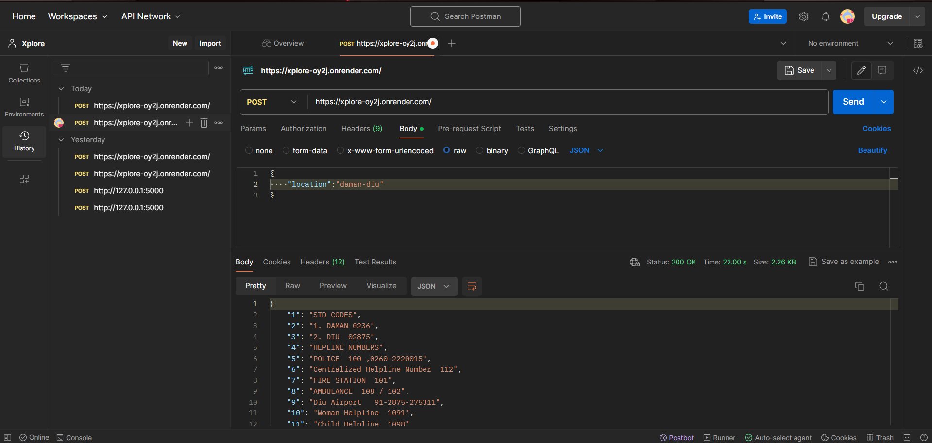

**API Link** - https://xplore-oy2j.onrender.com/

**MainActivity.java**

*package com.example.xplore;*

*import androidx.appcompat.app.AppCompatActivity;*

*import android.content.Intent;*

*import android.view.View;*

*import android.widget.TextView;*

*import android.os.Bundle;*

*public class MainActivity extends AppCompatActivity {*

*TextView txt_login, txt_signup;*

*@Override*

*protected void onCreate(Bundle savedInstanceState) {*

*super.onCreate(savedInstanceState);*

*setContentView(R.layout.activity_main);*

*txt_login = (TextView) findViewById(R.id.textView7);*

*txt_signup = (TextView) findViewById(R.id.textView12);*

*txt_login.setOnClickListener(new View.OnClickListener() {*

*@Override*

*public void onClick(View view) {*

*Intent Login = new Intent(view.getContext(), login.class);*

*startActivity(Login);*

*}*

*});*

*txt_signup.setOnClickListener(new View.OnClickListener() {*

*@Override*

*public void onClick(View view) {*

*Intent Signup = new Intent(view.getContext(), signup.class);*

*startActivity(Signup);*

*}*

*});*

*}*

*}*

**Login.java**

*package com.example.xplore;*

*import androidx.appcompat.app.AppCompatActivity;*

*import android.content.Intent;*

*import android.view.View;*

*import android.widget.Button;*

*import android.os.Bundle;*

*public class login extends AppCompatActivity {*

*Button btn_mainPage;*

*@Override*

*protected void onCreate(Bundle savedInstanceState) {*

*super.onCreate(savedInstanceState);*

*setContentView(R.layout.activity_login);*

*btn_mainPage = (Button) findViewById(R.id.button2);*

*btn_mainPage.setOnClickListener(new View.OnClickListener() {*

*@Override*

*public void onClick(View view) {*

*Intent mainPage = new Intent(view.getContext(), landingPage.class);*

*startActivity(mainPage);*

*}*

*});*

*}*

*}*

**Signup.java**

*package com.example.xplore;*

*import androidx.appcompat.app.AppCompatActivity;*

*import android.content.Intent;*

*import android.view.View;*

*import android.widget.Button;*

*import android.os.Bundle;*

*public class signup extends AppCompatActivity {*

*Button btn_signup;*

*@Override*

*protected void onCreate(Bundle savedInstanceState) {*

*super.onCreate(savedInstanceState);*

*setContentView(R.layout.activity_signup);*

*btn_signup = (Button) findViewById(R.id.button);*

*btn_signup.setOnClickListener(new View.OnClickListener() {*

*@Override*

*public void onClick(View view) {*

*Intent login = new Intent(view.getContext(), login.class);*

*startActivity(login);*

*}*

*});*

*}*

*}*

**LandingPage.java**

*package com.example.xplore;*

*import androidx.appcompat.app.AppCompatActivity;*

*import android.os.Bundle;*

*public class landingPage extends AppCompatActivity {*

*@Override*

*protected void onCreate(Bundle savedInstanceState) {*

*super.onCreate(savedInstanceState);*

*setContentView(R.layout.activity_landing_page);*

*}*

*}*